Product Catalog | AC/DC Power Connector
Connector type | DC Power Socket
Mounting Type | Bent Pin
Contact Inner Diameter | -
Contact Outer Diameter | -
Rated Current | 5A
Rated Voltage | 20V
Operating Temperature Range | -25℃~+70℃
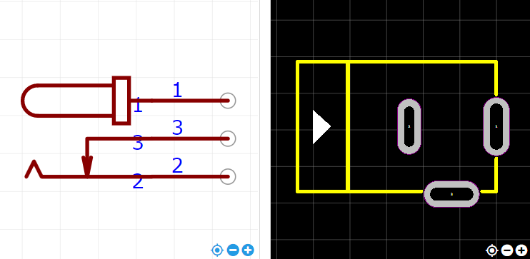
https://item.szlcsc.com/419795.html

